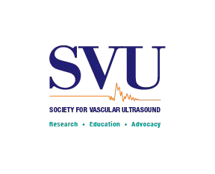
Signature School Member Application
Effective immediately Membership Expiration: December 31, 2021

Invoice Date:

- Please help us maintain accurate records (indicate any changes below in your preferred mailing address):
Name Address 1
Address 2 City State Zip
Please provide your email address and other contact numbers so we can reach you with important information.
E-mail (specify: home or work): Work Phone Work Fax Home Phone

1 a. Are you interested in volunteering with SVU? Please select all that apply:
Mentee Committee Ambassador to vascular schools

1 b. Please note if you would like to receive the print version of JVU, in addition to your current online access. : YES NO

- Please select all that apply:

List your expected date of graduation:
/ /

Calculate membership dues payment
  - Student ($25/pp)
  - Faculty liaison* ($10 off)
*1st liaison only
Optional voluntary contribution to:
Advocacy Fund $ Anne Jones Scholarship $ TOTAL $

**Approximately 20% of your annual dues will be used for advocacy expenditures. That amount is not tax deductible.

Submit your application and payment to your faculty liaison

Degrees: | Certifications: | Other organizations you belong to:
AS | RVT | SDMS
AA | RDMS | SVS
BS | RDCS | SVM
BA | RPVI | SVN
BSN | RVS | ASE
MS | RN | AVLS
MA | CVN | ASN
MSN | LPN | ARRT
Med | LVN | SRU
MBA | RT | ACC
MD | RTR | AIUM

DO CRT
PhD RRT
ScD RPhS
JD Other: Other:
Other:

Thank you for your continued support of SVU!
4601 Presidents Dr., Suite 260, Lanham, MD 20706-4831 ⏐ tel 301-459-7550 ⏐ fax 301-459-5651 ⏐ www.svu.org

