Dear SVU Board, Committee Chairs and Members, and other Volunteers:
Below please find the instructions for entering your Conflict of Interest Disclosure Statement and Confidentiality Agreement in the SVU database. By doing so as part of your SVU member profile, you will only need to edit or re-affirm your statements annually—no more forms for scanning and faxing, and no more paperchase for staff!
Instructions in Brief:
- Review and understand the SVU Confidentiality and Conflict of Interest Policy.
- Follow this link and login to your SVU account
- Click on “Personal Info” button on left hand side
- Scroll down to bottom of page; Confidentiality and Conflicts of Interest Disclosure information is listed below Donation Information
- Enter your Conflicts and/or Disclosures in the two open text fields; and check the 4 boxes.
- After entering your disclosures, you must click on SAVE at the very bottom!!
- Remember: It is YOUR responsibility to declare your conflicts of interest; update them during the year as circumstances change; and alert the Chair (President) if a situation or issue being discussed could be interpreted as a conflict of interest.
Instructions with Screen Shots:
- Log into your account on svu.org
- Click on “Personal Info” button on lefthand side (see screenshot below)
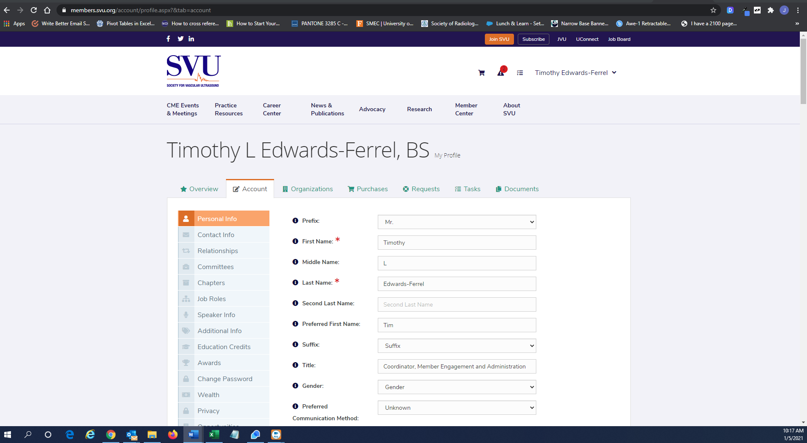

- Scroll down to bottom of page; Confidentiality and Conflicts of Interest disclosure information is listed below Donation Information (see screenshot below)

- After entering your disclosures, you must click on SAVE at the very bottom!!

