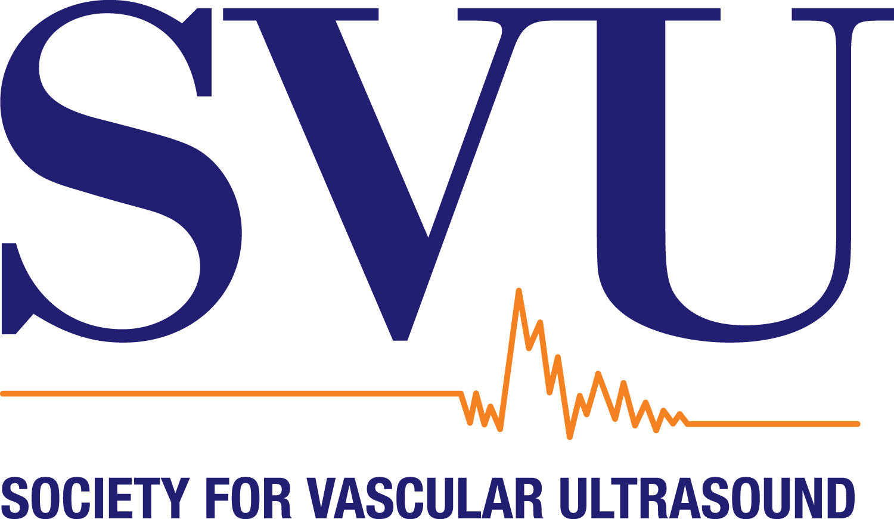

Society for Vascular Ultrasound Annual Conference 2026
Attendance Justification Letter

<DATE>

Dear <SUPERVISOR’S NAME>,

I would like to attend the Society for Vascular Ultrasound 2026 Annual Conference July 30 - August 1, 2026, in National Harbor, MD. Attendance at this conference will enable me to attend educational sessions, as well as have access to leading vascular experts and the latest technologies in the SVU Marketplace.

Attending this conference, I will be able to:
- Earn up to 19 SVU CME credits to help go towards my RVT/RVS renewal requirement and our vascular lab accreditation requirement.
- Bring back new ideas on formulating treatment plans and improving practice management.
- Network with over 250 vascular professionals to market our vascular lab and to learn from other professionals.
- Engage with a variety of vendors to view and try out new machines and software that could be used in our vascular lab.

With the current economic conditions, I understand we must be very conscientious of where we spend money. Therefore, I have broken down the costs for me to attend this conference. The conference registration will cost <$XXX>, which includes all lunches during the conference, the hotel will cost <$XXX> per night and the flight/drive will cost <$XXX>. For the reasonable price of <$XXX>, I can attend SVU’s 2026 Annual Conference. I believe attendance at this conference is a prudent investment in our vascular lab’s future.

Sincerely,
<YOUR NAME HERE>

